Report

Date | 20-September 2026
Team ID | MCA
Project Name | Smartphone Usage & Digital Addiction and Well-Being Analytics
Maximum Marks | 5 Marks

A report is a comprehensive document that presents the analysis, findings, and insights obtained from the Smartphone Usage & Digital Addiction and Well-Being Analytics dataset. The report helps users understand smartphone usage patterns and their relationship with digital addiction, sleep, stress, physical activity, and overall well-being.
The Power BI report was designed using interactive visualizations such as bar charts, pie charts, line charts, cards, and slicers. These visualizations provide a clear understanding of smartphone usage behavior and help identify patterns that may be associated with digital addiction and well-being.
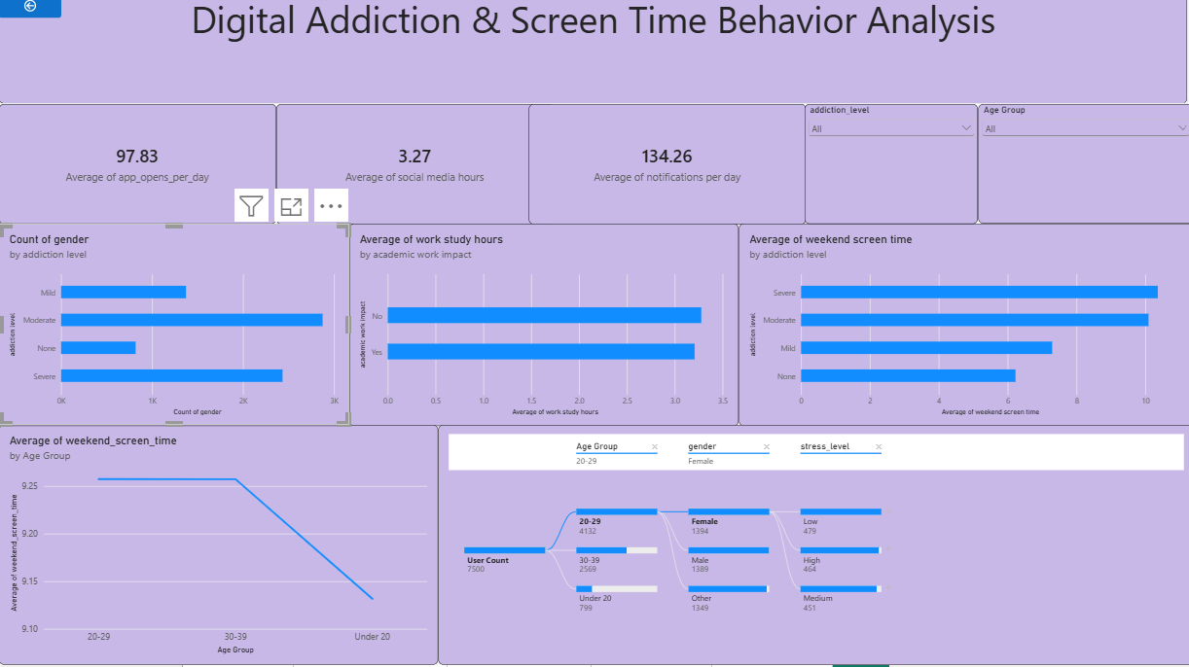

Observations drawn from reports in Power BI can provide valuable insights into business performance and trends.
1. Trends Over Time:
Analyze how smartphone usage, screen time, and digital addiction levels change over different time periods to identify usage patterns and trends.
2. Usage Comparisons:
Compare smartphone usage across different age groups, genders, or user categories to identify groups with higher or lower screen-time levels.
3. Digital Addiction Analysis:
Assess digital addiction levels among users to understand the distribution of low, moderate, and high addiction levels and identify groups that may require attention.
4. Well-Being Analysis:
Analyze the relationship between smartphone usage and well-being indicators such as sleep duration, stress levels, and physical activity to understand lifestyle patterns.

Example:
Screen Time Analysis:
The screen-time analysis indicates that users with higher daily smartphone usage contribute significantly to overall screen-time consumption. This highlights the importance of monitoring excessive smartphone usage.
Digital Addiction Analysis:
The digital addiction chart shows the distribution of users across different addiction levels. Users with higher smartphone usage tend to appear more frequently in the higher addiction categories, indicating a need to understand digital usage habits.
Sleep Analysis:
The sleep analysis shows differences in sleep duration among users with different levels of smartphone usage. Users with higher screen time can be compared with lower-usage users to identify differences in sleeping patterns.
Stress and Well-Being Analysis:
The report indicates variations in stress and well-being levels among users. Comparing these indicators with smartphone usage helps identify patterns between digital habits and overall well-being.
Physical Activity Analysis:
The physical activity analysis compares users' activity levels with their smartphone usage. This helps identify differences in physical activity patterns among users with different levels of screen time.
